Meta Description:
Technical SEO is a way to improve a website's search engine ranking by upgrading all technical aspects of the website. It involves fixing crawling and indexing issues.
https://drive.google.com/drive/folders/1O9o73B9DBI9u-R1KOH9lY-pfmb9ytw-S

What Is Technical SEO & How to Do it Effectively in 2025

In the current era of globalization, SEO has emerged as a critical tool in the modern world for creating awareness about a business for various stakeholders.
In SEO, no one can deny the role of technical SEO in improving user experience along with website speed and functionality.
In this blog, we will understand what Technical SEO is all about, how it is distinct from the other types of SEO, as well as why Technical SEO is vital to SEO management.

What Is Technical SEO?
Technical SEO refers to the optimization of the code and other aspects of the website’s architecture in a way that makes it accessible to search engine bots and crawlers.
In other words, Technical SEO is a method of enhancing the technical features of a website in a manner that would make it rank highly in the SERP.
Factors like website speed, the website’s ability to load on different devices, URL structures, and sitemaps, are major factors that come under the jurisdiction of technical SEO.
By paying specific attention to these features, the user experience will be improved, rates of bounce depreciated and conversion-optimized.

Key Components of Technical SEO:
Here are some key components of technical SEO, you must be aware of:
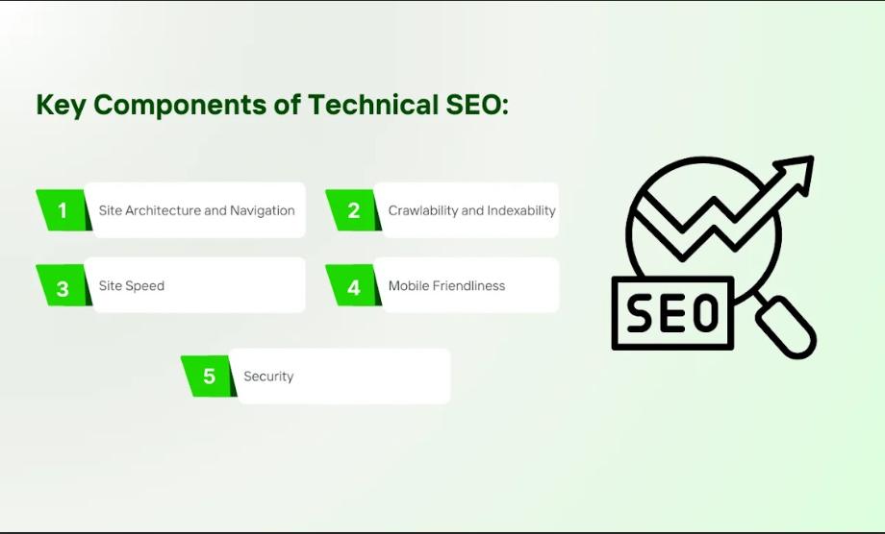
- Site Architecture and Navigation: The correct arrangement of links on a website, or an easy site map, will assist the search engines in identifying the structure and prioritization of your site more easily.
- Crawlability and Indexability: Website pages should be easily accessible by the bots to enable crawling and indexing of the site.
- Site Speed: This aspect of a site refers to the amount of time it takes for the page to open. Site Speed has a direct influence on user experience, the better this aspect is, the better rankings.
- Mobile Friendliness: As the mobile usage for browsing increases it is best that your website is mobile friendly.
- Security: HTTPS through the use of SSL certificates makes it easier to gain people’s confidence. Therefore, this will make you move up the rankings.

How Technical SEO Differs from On Page and Off Page SEO?
SEO has been subdivided into three major categories, namely on-page, off-page, and technical. However, each of them has its unique function in the context of the general SEO plan. Let’s discuss each type to achieve more clarity:
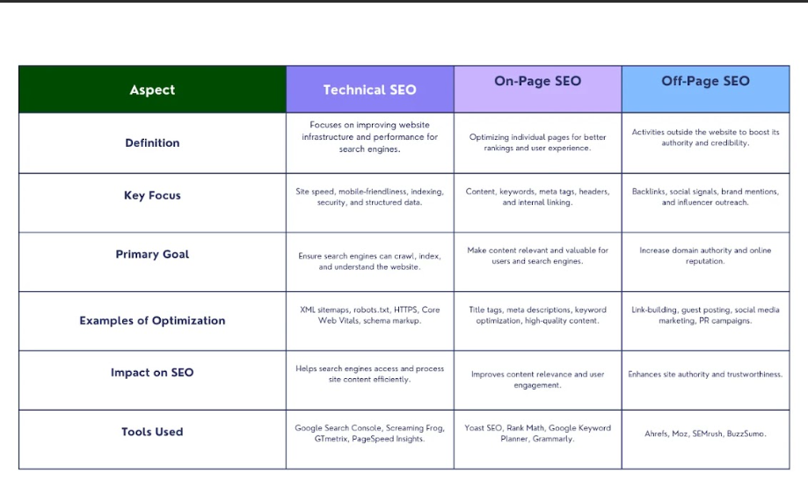
- Onsite SEO: This deals with techniques that are done on the website with the aim to improve crawling, and gain better traffic rates or ranking. It concerns such factors as the quality of published content, keywords (Difficulty and Volume), META tags, and internal linking.
- Off-page SEO: This is an exercise carried out outside of the website to influence standings on SERPS. It mainly entails increasing the number of links that are directed to the site in order to improve the website’s popularity and reliability.
- Technical SEO: It is different from the on-page and off-page in the sense that it deals with the technical aspects of a website. In theory, it helps to ensure that the construction of the site’s base is strong and gives the search engine adequate opportunity to crawl the site for proper indexing. It consists of factors like website structure, response time, and responsiveness on different mobile devices.

Why Technical SEO is a Foundation for SEO Success?
Technical SEO could be referred to as the foundation of every proper SEO approach.
It means that even if the content of the website is good and there exist many backlinks, still website will not rank well if technical issues exist.
Technical SEO will make your site indexable and crawlable for search engines, which is very important for its general success in the field of SEO.

The Importance of Technical SEO:
Technical SEO carries great significance in terms of enhancing search engine crawlability and indexing, improving user experience, boosting organic ranking, and reducing website errors, Let’s discuss each aspect in more detail.
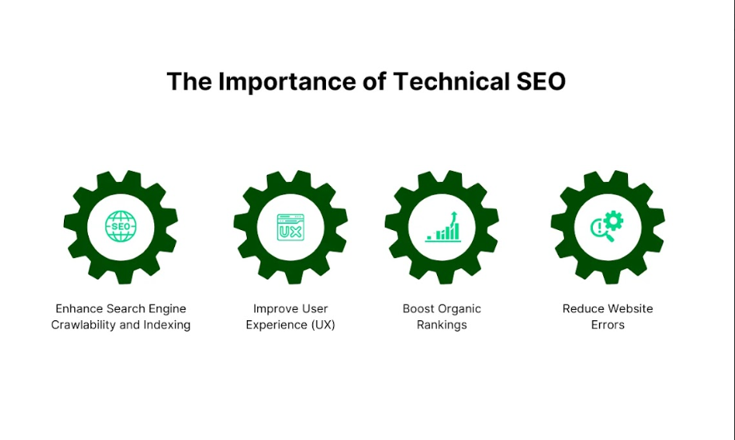

Enhance Search Engine Crawlability and Indexing:
A major task of technical SEO is to improve the crawlability and indexation of your website for search engine bots.
Crawlability is the access of the search engine bots to all the pages of a site.
The simple truth is if a bot cannot access your website pages, then they will not be indexed and cannot be retrieved through a search.
Technical SEO resolves this by proactively including a well-structured sight map, the efficient use of robots.txt files, and URL reconstruction.
Indexing on the other hand is the process by which the search engines place the web pages into their database.
Technical SEO makes your website crawler-friendly to achieve a properly blocked and encoded HTML and to avoid issues through the proper use of self-reference.
Sitemaps must also be made, as they provide search engines with a guide on the location of the content of your site.

Improve User Experience (UX)
Technique SEO is already involved with UX, as UX is a crucial element for search engines and the persons using them.
Ease of access, load time, and menu options and layouts on websites give the visitors a good experience.
Additionally, Google, and other search engines algorithms also take into consideration UX as a ranking factor.
So, this means, that by implementing certain technical changes to your website, you can improve UX which ultimately can increase the ranking. Here are different ways to improve user experience:

- Page load speed: Refers to website loading time and slow-loading websites are likely to deter website users which leads to high bounce rates. Image optimization, browser caching and minimizing of use of JavaScript are the ways to enhance the loading times.
- Mobile Optimization: Regarding modern trends, mobile accounts for a significant number of visits. Having a website adequately optimized to accommodate the mobile client is very crucial. Technical SEO involves optimization of the website by ensuring that it performs well on various devices of display.
- Smooth Flow: While designing a website, the enhanced flow of a website enables the users to locate the wanted information easily with the help of navigation. Technical search engine optimization addresses through proper URL construction and organization of the website’s structure.

Boost Organic Rankings:
Technical SEO is a sure way of enhancing the position of your website on search engine results ranking.
Technical SEO serves to facilitate the web crawlers to access as well as index your site in a bid to reach the targeted consumers.
Moreover, technical SEO also works on other aspects like fast loading time and the website’s adaptability to mobile devices, which also enhances ranking.

Reduce Website Errors:
There are many common errors on a website that can affect the SEO results of the website technically.
Technical SEO entails such aspects as the identification of problems for instance broken links, duplicate content, or crawl errors among others.
Such problems can be found using tools such as Google Search Console and Screaming Frog, which would let you fix those problems on the spot.
- Broken Links: This can partially or fully degrade some or all the needs of the users and does not give your site and its content a good reputation. Technical SEO, as one of the most important elements of SEO, periodically analyzes your website to address such problems as broken links.
- Duplicate Content: This is a problem that can baffle search engines as well as deprive your website of the best ranking. Regarding the utilizations of Technical SEO, canonical tags are used to inform what the website’s preferred version is.
- Crawl errors: crawl errors refer to conditions under which search engines are unable to access some of the web pages. Technical SEO resolves that issue by implementing the standards of robots.txt files as well as the proper use of meta tags.

What is Crawling & How to Optimize for It?
SEO in this era of digital marketing ensures that your website is ranked well in the search engine results.
Another factor of the SEO is the concept of crawling which is very crucial for any site. The concept of crawling informs us how search engines, including Google, index the content of your website on the basis of different evaluation factors. That’s why you must know about crawling, the element that influences it and how to enhance the crawling process for your website.

What is Crawling?
It is the first step of the SEO process commonly referred to as crawling.
It entails search engine bots, also referred to as spiders or crawlers, to tour your website to index its content.
When a crawler visits a site, it downloads the code of the page and along with it navigates through all the other pages of your site.
The information obtained in this process is then applied to the indexing process which basically involves placing the pages into the database of the search engine.
If a search engine is not able to crawl, your site’s content then it will not be indexed for the search and therefore will not show up on a search.

Key Factors That Impact Crawling:
There are several factors which determine the extent to which search engines can crawl your website. These can be useful for making further changes for better exposure of your website.

1. Site Speed:
The rapid website loading is a decisive factor for crawling. Websites have high rankings with popular search engines when they load faster and are user-friendly.
If the page takes too long to download, the crawlers may leave the site prematurely and this means incomplete indexing will have occurred.
Use image resizer, enable browser caching, and reduce the size of JavaScript and CSS files for your site’s speed boost.

2. Robots.txt Files:
Robots.txt is a plain text file placed in the root directory of a website that provides instructions to web robots about the pages of the site that should not be processed.
Although this is useful for restricting access to some portions of your website, flaws in this setting may result in the limitation of the site’s pages from indexing.
Make sure that your robots.txt has been well configured to permit crawlers to crawl through the content that they are to index.

3. XML Sitemaps:
It is a file that contains information about all the pages of your site, and enables search engines to crawl through the site effortlessly.
The sitemap XML file is created to help search engines index a large number of pages and also to help crawlers easily navigate through a large website.
It is always important to make sure that you make corrections to your sitemap as often as possible to depict the newer structure of your site.

Best Practices for Crawl Optimization:
Below are some of the best practices to follow if you want to improve your website to be crawled and indexed well:

1. Ensure a clean and logical site structure:
This way the crawlers can move through your site with more ease which makes it easier for them to crawl through your site.
One more thing which will prove beneficial to your website is to make a clear hierarchical sense that assist the search engines to crawl on the site with much ease. This means no extra subdomains and improving the usability of the menu bar.

2. Avoid crawl traps and duplicate content:
Another problem faced is crawl traps where the spiders find themselves in loops or are guided to the wrong pages during crawling.
Do not generate multiple versions of the same page by referencing preferred URLs using the canonical links.
Always go through your site and look for any signs of crawl traps and involuntarily remove them.

3. Use Internal Linking Strategically:
Internal links not only ease the users’ website navigation but also show the crawlers where to go next.
If you decide to have internal links, then you should provide proper descriptions of the linked keywords and make sure they link only to the most relevant content.
It is to know how to plan internal linked appropriately so as to enhance the site’s ability to be crawled and also improve on the SEO factor.

What is Indexing & How to Optimize for It
Here we will discuss what indexing is and the elements that determine it as well as giving examples of the right steps to take when indexing a website.

What is Indexing?
Indexing, on the other hand, is a way by which search engines find your website content to provide a search result when someone searches for information.
Just image the 3.5 billion people using the Internet are searching for books and the Internet the library. Similarly, in the same way, that a library catalogs a book to enable one to search it out amongst the other books, search engines index web pages to permit one to search the web page among the other web pages.

When a search engine comes across your site, it scans it and categorizes your web pages according to some criteria.
This indexed content is then employed to give relevant search results to customers. When an individual cannot be able to find your website’s pages, it means they appear extremely low when searched on engines.

Factors That Influence Indexing:
The following are several factors that can affect the degree of indexing of your website. It is very necessary to comprehend all these factors so that your site can be well placed in the end.

Canonical Tags:
It is an HTML meta tag that tells search engines which of the two or more pages is the original one to help with crawling.
This is the preferred way to avoid copyright infringements on submitted content.
Duplicate content when indexed on different URLs can nearly weaken the entire SEO process.
Proper use of canonical tags allows to point search engines to the chosen URL, which allows indexing the appropriate version of the page.
This helps in retaining the link juice and avoiding the issue of having similar pages being indexed.

Meta Robots Tags
Meta robots tags are special codes used by different search engines to determine what to do with the site’s individual pages.
These tags can be used to set the display mode of certain pages in the website or selected parts of the web page.
For instance, the use of a meta robots tag that instructs that a certain page should not be indexed means that it will not be indexed by the search engines.
On the other hand, a follow is the directive that tells the search engines to follow the links on a particular page while a nofollow is the directive that instructs the search engines not to follow the links on that specific web page.
By correctly applying the meta robots’ tags, you can keep search engines off the site in case that is your wish or to index your site fully as desired.

Structured Data:
Structured data is a format of describing a page and the type of content present on the particular page.
This enables search engines to better identify the context of the content within your site to index it correctly.
This method helps to make your content more responsive in the search and structured data lets it stand out.
For instance, structured data is helpful when the data is to be used to form rich snippets which are additional information to the basic search information such as property rating, user review, or the price of the issue.
Moreover, this enhances your chances of making the most of your listings and also makes them more user-friendly.

Best Practices for Index Optimization
Here are some recommended guidelines in the process of indexing that make all pages on your website reachable by search engines.

Ensure all important pages are indexable:
The first concept in optimizing for indexing is to ascertain that all the pages of the website you are creating can easily be indexed.
This involves confirming that your pages may not be disallowed by robots.txt files or by meta robots’ tags with a “no index” setting.
Also, all the pages must be linked internally because this will help search engines identify and index the pages.

Use Canonical Tags to Prevent Duplicate Content Issues:
Canonical tags are important for avoiding problems with reposting materials on the same site or other sites.
It firstly remains crucial to use the canonical tags properly in your website, especially for those websites that have similar pages or the same URLs.
It assists the search engines in identifying the preferred version of the website pages.

Leverage Structured Data to Enhance Content Understanding:
The use of structured data is an efficient process when it comes to improving the comprehensibility of the content by search engines.
Schema markup gives specifics of the content of the page, and it covers aspects like articles, events, products, and reviews among others.

Quick Wins for Technical SEO
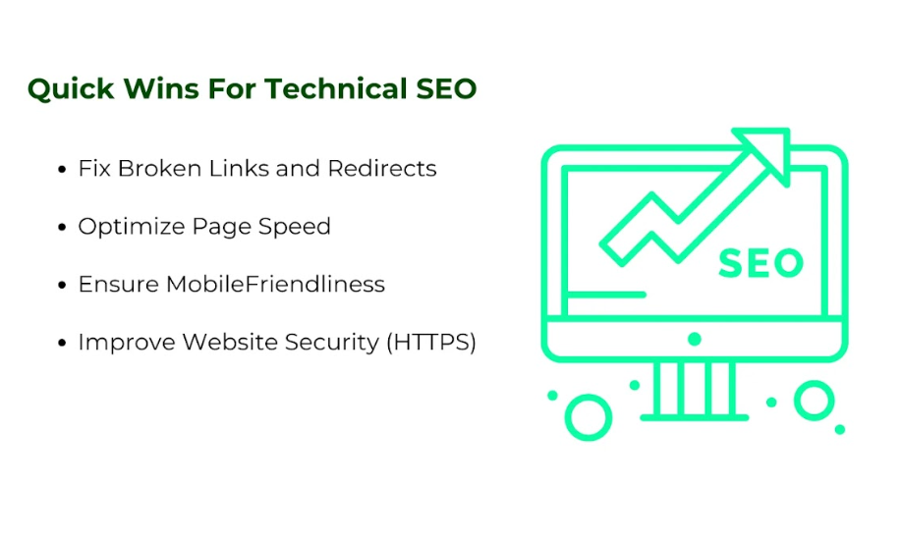

Fix Broken Links and Redirects:
404 errors and incorrect redirection negatively affect users and crawling processes on the site. To avoid this, you should perform a weekly or monthly check on your website to ensure that all links are working properly. Ensure that moving or deleted pages are redirected to the new or appropriate ones using the 301 method to retain link juice.

Optimize Page Speed:
This factor is one of the ranking factors and stands as significant because the page loading speed is important for the users. Implement strategies like:

- Image Compression: This uses image file shrinking tools like TinyPNG to minimize the size of images being used on the site without having to sacrifice the quality of the images.
- Browser Caching: It should be enabled to allow the saving of the most frequently accessed files and resources in clients’ devices.
- Minimization of JavaScript: It is also important to minimize JavaScript files to enable quick loading of the website.

Ensure MobileFriendliness:
Given the fact that over half of web traffic is generated through mobile devices, a mobile-first approach cannot be an optional. Always take into account best practices in Web design as well as adapt your site to all possible screens and orientations.

Improve Website Security (HTTPS):
The main reason for switching to HTTPS is to create a sense of safety not only for the transmitted data but also for users and search engines. Indeed, getting an SSL certificate enables data encryption and drives up the credibility and SEO rankings of any website.

Additional Technical SEO Projects for Long-term Success:

Implement Structured Data Markup:
Semantic information regarding the data boosts the chances of a better placement on the SERP page through rich snippets as well as results in better indexing by the search engines. Add more information by using schema markup to give more meaning to what is being displayed.

Optimize Core Web Vitals:
There are certain factors that Google pays primary attention to and these are all referred to as Core Web Vitals. Focus on:
- Largest Contentful Paint (LCP): Optimize for faster loading of the largest visible content.
- First Input Delay (FID) latter: This deals with the application’s response to the first user input, and it is done to reduce delay.
- Cumulative Layout Shift (CLS): There is also that parameter called Cumulative layout shift that counters rather nasty phenomena, disrupting a web page’s layout.

Improve International SEO:
If your business is using your sites to target an international audience, you should use the proper implementation of hreflang tags to determine language and geographical location. You should pay attention to such components as the translation of the content to suit the target markets.

Audit and Fix Duplicate Content:
Duplicate content harms the search engine ranking because the search engine gets confused between what content is original and what needs to be indexed. Conduct regular audits to check and merge the duplicate pages that are present on the website with the help of canonical tags or resource consolidation.

Essential Technical SEO Tools:
Here are some most effective technical SEO tools that help your website in one way or another:

Crawling and Indexing Tools:
- Screaming Frog: A fodder that sets up good for crawling and the subsequent audit of your website.
- Ahrefs: Useful for providing complex Technical SEO services, including the site audits.
- SEMrush: Provide information on the site’s crawlability and potential indexation problems.

Page Speed Optimization Tools:
- Google PageSpeed Insights: Here the site owner is given an understanding of site speed.
- GTmetrix: Provides an insight into the performance of the given page.
- Lighthouse: This is a free tool that is used for auditing web pages that are already incorporated in Chrome DevTools.

Structured Data Testing Tools:
- Google’s Rich Results Test: Helps to determine whether the structured data qualifies for the rich results.
- Schema Markup Validator: Validates your schema markup for errors.

Comprehensive SEO Platforms:

- Moz: Provides a suite of tools for technical SEO management.
- DeepCrawl: Offers in-depth analysis of your site's technical health.

Conclusion:
Technical SEO should be incorporated into any overall SEO plan as one of the critical elements. It is a technique that is intended to improve all aspects of a site that can affect its ranking by search engines.
Effectively, technical SEO enables easier and faster access to website content by search engine crawlers, improve user-friendly experience, provide better organic search result positioning, and minimized errors when it comes to website maintenance and structure.
Regardless of your level of experience in SEO, it is vital that you at least possess some knowledge of technical SEO and put it into practice so that your business can thrive in the current business environment.
Here at Three Angle Marketing, the leading SEO Services Agency, we help you solve all your issues related to technical SEO. Reach out to us today and get a solution to any of your crawling and indexing issues.

